**Detailed Business Specific Requirements:-**

**Theme**: Existing IT system for internal agencies of MoJS

**Applications**: WIMS expansion-WRIS

**Use Cases:-** Drought Affected Areas (2002)-**WRIS-SSA-08**

**Other linked Use Case :-** Drought Early Warning System* (DA-UC-01), Drought susceptibility map (DA-UC-02), Drought indicators (DA-UC-03), Drought outlook maps (DA-UC-04), Drought impact (DA-UC-05),Proactive management of Drought (DA-UC-06), Responses to Drought (DA-UC-07), Drought monitoring (DA-UC-08), Drought index (DA-UC-09), Ground Water Drought Index (GWM-UC-18),Crop production (IM-UC-07), Crop insurance (CWM-UC-14), Crop insurance (CWM-UC-14), Soil health index (CWM-UC-15), Soil Moisture (WRIS-MIS-13), Crop Water Requirement (CWR) (CWM-UC-04), Reservoir Storage status (RM-UC-02), Rainfall (WRIS-MIS-11).

**Description**:-

A drought is defined as "a period of abnormally dry weather sufficiently prolonged for the lack of water to cause serious hydrologic imbalance in the affected area.” –Glossary of Meteorology (1938). The occurrence of drought is

Cropping choices and agronomic practices, soil types, drainage and ground water profiles, to name a few. However rainfall deficiency and spatial and temporal distribution, duration and dry spells are acknowledged as the most important triggers for drought.

Drought Prone Areas Programme (DPAP) is the “earliest area development programme’ launched by the Central Government in 1873-74 to tackle the special problems faced by those iragile areas which are constantly affected by severe drought conditions. Based on the recommendations of Hanumantha Rao committee (1994) the programme has been under implementation on watershed basis since 1995. In 1977-78, Desert Development Programme (DDP) was launched for hot desert areas of Rajasthan, Gujarat, Haryana and cold desert areas of Jammu & Kashmir and Himachal Pradesh.

The Drought Prone Areas Programme wai operation in 627 blocks of 96 districts in 13 States during 1994-95. On the recommendation of the Hanumatha Rao Committee, 384 new blocks were brought into the purview of this programme and 64 were Transferred from DPAP To DDP. Consequently, Coverage of the programme was extended to 947 Blocks of 164 Districts in 13 States. With the reorganization of States, districts and blocks, at present the programme is under implementation in 972 Blocks of 182 Districts in 16 States namely Andhra Pradesh, Bihar, Chhattisgarh, Gujarat, Himachal Pradesh, Jammu & Kashmir, Jharkhand, Karnataka, Madhya Pradesh, Maharashtra, Orissa, Tamil Nadu, Rajasthan, Uttaranchal, Uttar Pradesh and West Bengal.

Similarly, in1989,Integrated Watershed Development Programme (IWDP) Was launched under the aegis of National Wasteland Development Board for development of wastelands onwatershed basis. A Common Guidelines for Watershed Development,2008 have been Issued and made effective from 1.4.2008. Since 26.2.2009, the three Watershed programmes of the Department Of Land Resources namely DPAP, DDP And IWDP have been consolidated as a comprehensive programme named ‘Integrated Watershed Management Programme (IWMP)*. This programme comes under Ministry of Rural Development.

**Used By (End Users):-** Researcher, Decision makers, administrators, academicians and public.

**Priority**:- **Medium Priority**

**Phase:-** **Subsumed: Phase 1**

**Governance Need (Business Problem):-**

**Issue**:-

1. Activities under DPAP /DDP are not spread over the entire length and breadth the problem areas, but are restricted to identified smaller areas, it would be logical to expect the impact of these programmes only over such limited areas. “The programmes have been implemented in a fragmented manner by different departments through rigid guidelines without any well designed plans prepared on watershed basis by involving the inhabitants. Except in a few places, in most of the cases the achievements have been dismal. Ecological degradation has been proceeding unabated in these areas with reduced forest cover, declining water table and a shortage of drinking water, fuel and fodder” (Hanumantha Rao Committee, 1994, Preface).
2. Watershed wise data on the performance evaluation is absence for these programmes.
3. Of the many factors responsible for the unsatisfactory performance of the Programmes, the most important one is that under both the programmes, a wide range of activities not necessarily related to the core objectives were taken up in the past by spreading them thinly over a widely dispersed area. This tended to defuse focus on efforts to be made for achieving the core objectives of the Programmes. The attempt at mitigating the sufferings of the people were aimed at the provision of adhoc relief through income generating activities funded from the area development programmes without integrating such works with programmes for land and water conservation.
4. There is no appropriate mufti-disciplinary agency at the district, block and the watershed level to prepare integrated plans which could be taken upfor implementation.

**Approach**:-

1. For overall success of any development programme, essential data which are crucial for watershed planning should be made available with the planners at the district and block levels.
2. It is necessary to organise independent evaluation studies on a large scale and on a regular basis.
3. Through the active involvement of the people, these types of schemes will improve the environment and productivity of resources.
4. Updated data from concerning government agency (data of IWMP) is required to be incorporate to enhance the information covered under this module.

**Output:-** Showing The information on drought and desert prone areas at block level scale.

**Expected Outcome:-** The information on two main themes i.e.

1. Areas under Drought Prone Development and Desertification Development –The information shows the area in sq. km, which is identified under DDP, or DPFAP programme in each block.
2. Tribal Sub-Plan Areas Of the Country –Tribal sub Plan Area (MoRD), Pockets Of Tribal Concentration & Predominantly tribal areas.

**Visualization:-**

**A) Map at India Level** –

a) Drought Prone Development and Desertification Development data visualization -district/block wise.

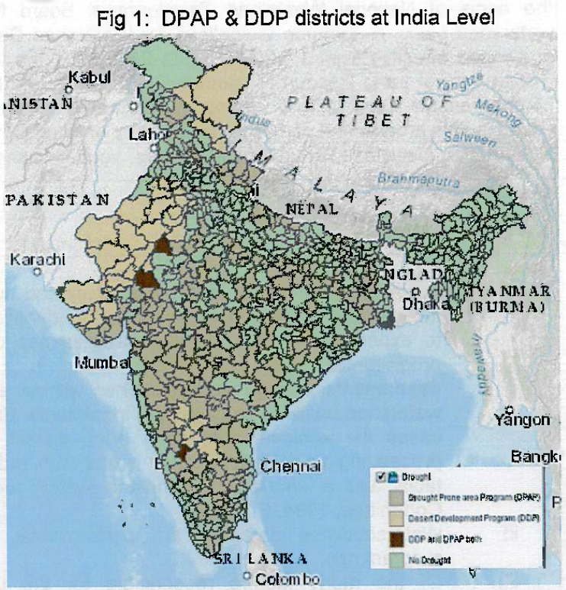

b) Tribal sub plan area details — district wise tribal sub plan area information, the state/UTs having pre moninant tribal population along with the pockets of tribal concentration areas of the country.

**2. Area statistic of drought data**

1. Area statistics administrative unit wise-state/district
2. Area statistics administrative unit wise-district/block.

**3. Bar/Pie diagram - District wise and Basin wise chart option.**

**4. DPAP Vs DDP block visualisation —district/block wise.**

**\*Selection/query and data visualization of the Desert Development Programme (DDP) & the Tribal Sub Plan Area MoRD will also be in the same way like that of the Drought Prone Areas Programme (DPAP) as shown above. All the information of DDP, DPAP & tribal sub plan areas of MoWR are entered into the respective layers as non spatial tables.\***

**Frequency of Up-dation:-** As per data made available by Ministry of Rural Development.

**Measure of Success:-** The information on drought and desert prone areas in the country as declared by Ministry of Rural Development, Department of Land Resources, Govt. of India will be compiled under the module. User will get the information on the “earliest area development programme” launched by the Central Government in 1873-74 to tackle the special problems faced by those fragile areas which are constantly affected by severe drought conditions.

**Input Data Required:-**

**Geospatial Data:**

Frequency: One time published Data

(District/Blocks identified and published as drought prone area by MoRD and categorized under DPAP & DDP as well as tribal sub plan area information as per the MoRD.

Resolution : NA.

Extent of Coverage: Country level data

**Process:**

**Algorithm/Tools:-**

The integration of the DPAP, DDP and Tribal sub plan area data in to the Drought Affected Areas (2002) module will require following steps-

**Step 1:** For the declared districts/blocks under DDF/DPAP schemes & Tribal sub plan area, the administrative block, district and state boundaries will be used.

**Step 2:** Information will be entered as non- spatial tables of the vector data.

**Step 3:** GIS schema preparation, attribute finalization, data standardization, relationship establishment among different features.

**Step 4:** Preparation of map document of drought data layers with proper label, legends, scale and suitable visibility of layers at varying scales.

**Step 5:** Hosting GIS layers in the Drought Affected Areas Module. Documentation of the data visualization in the website. Spatial vector data will be accessed through QGIS server at production site.

**Step 6:** Development of GIS tools for query based on the user defined inputs.

**Data Validation:-** GIS data schema checking, relationship validation as well as attribute checking. Need proper

validation process before dissemination of data into the public domain.

**Software Technologies:-**  QGIS Desktop/ QGIS Enterprise

**Dependencies & Risks:** Data availability from concerned agencies. Data manipulation & data vetting.

**User Acceptance Testing (UAT):-** NWIC

**Development Responsibility:** NWIC

**References :-**

1. Report on the working group of sub-committee of the National Development Council (NDC) on dryland/rainfed farming system including regeneration of degraded/wasteland, watershed development programme.
2. Report of the. Technical Committee on. Drought Prone Areas. Programme and Desert Development Programme. Ministry of Rural Development. April — 1994.
3. MANUAL FOR DROUGHT MANAGEMENT DECEMBER 2016 (Updated upto December 2020). Department of Agriculture and Farmers Welfare Ministry of Agriculture and Farmers Welfare Government of India New Delhi.
4. <https://indiawris.gov.in/wris/#/Drought>
5. <https://indiawris.gov.in/wris/#/Compendium-> India WRIS Module Description and Data Assessment Report.

**---End of Document---**